# VISVESVARAYA TECHNOLOGICAL UNIVERSITY

## “JNANA SANGAMA” Belagavi, Karnataka- 590 018



2025-2026

A Report On

**“Social Connect and Responsibility”**

**Subject code: BSCK307**

**Submitted in partial fulfillment of the requirement for the award of the degree of**

## “Bachelor of Engineering in Computer Science & Engenieering

## Submitted By

**Prabhudev B**

**[1AH24CS127]**

**Under the Guidance of**

**Ms Divya S**

**Assistant Professor,**

**Dept of Computer Science & Engenieering**



**Department of Computer Science &** Engenieering

**ACS COLLEGE OF ENGINEERING,**

**Kambipura Mysore Road, Bangalore- 560 074**

# ACS COLLEGE OF ENGINEERING

## Kambipura Mysore Road, Bangalore- 560 074

**DEPARTMENT OF COMPUTER SCIENCE & ENGENIEERING**



# CERTIFICATE

This is to certify that Mr. Prabhudev B bearing university register number **1AH24CS127** carried out **“Social Connect and Responsibility” (BSCK307)** as per VTU Curriculum, in partialfulfillment of award of the degree of **Bachelor of Engineering in Computer Science & Engenieering from Visvesvaraya Technological University, Belgaum** during the year **2025-2026**. The subject report has been approved as it satisfies the academic requirement in respect of Internship presentation prescribed for the degree.

|  |  |
| --- | --- |
| _ | _______________________ |
| Signature of Faculty Incharge | Signature of HOD |
| **Ms.Divya S**  **Asst Professor** | **Dr Nandha Gopal S M**  **HOD** |
| Dept. of Aeronautical Engineering | Dept. of  Computer Science & Engenieering |
| ACSCE, Bangalore | ACSCE, Bangalore |

## ACS COLLEGE OF ENGINEERING

### Kambipura Mysore Road, Bangalore- 560 074

**DEPARTMENT OF COMPUTER SCIENCE & ENGENIEERING**



# DECLARATION

I, Prabhudev B the student of third semester of Computer Science & Engenieering, ACS college of Engineering, Banglore-560074, declare thatthe report entitled “Social Connect and Responsibility” has been successfully completed under guidance of Ms.Divya S, Asst Professor,Department of Computer Science & Engenieering, ACS College OF Engineering, Bangalore. This dissertation work is submitted to Visvesvaraya Technological University in partial fulfillment of the requirements for the award of degree of Bachelor of Aeronautical Engineering during the academic year 2025- 2026.

|  |  |
| --- | --- |
| Place: Bengaluru | Prabhudev B |
| Date: 17/1/2026 | [1AH24CS127] |

**ACKNOWLEDGEMENT**

It is my proud privilege and duty to acknowledge the kind of help and guidance received from several people in preparation of this report. It would not have been possible to prepare this report in this form without their valuable help, cooperation and guidance.

First and foremost, I wish to record my sincere gratitude to the

**Management of ACS College of Engineering** and to our beloved Principal, **Mrs B.S Shylaja**, ACS College of Engineering, Bangalore for her constant support and encouragement in preparation of this report and for makingavailable library and laboratory facilities needed to prepare this report.

My sincere thanks to **Ms Divya S,** Asst Professor, Department of Computer Science & Engenieering ACSCE, for his valuable guidance and allowing us to conduct investigations for this project. The numerous discussions with him were extremely helpful. I hold him in esteem for guidance, encouragement and inspiration received from him.

My sincere thanks to all professors for supporting the work related to this project. Their contributions and technical support in preparing this report are greatly acknowledged.

Finally, I thank my family, friends and all those who always encouraged me and helped me in all the possible ways for my studies. I wish to thank my parents for financing my studies in this college as well as for constantly encouraging me to pursue engineering. My parent’s personal sacrifice in providing this opportunity to pursue engineering is greatly acknowledge

Prabhudev B

[1AH24CS127]

**CONTENTS**

|  |  |  |
| --- | --- | --- |
| SL.No | Contents | Page No. |
| 1 | Syllabus | 6 |
| 2 | Introduction | 7 |
| 3 | Module-1:- Plantation and Adoption of a  Tree | 8-10 |
| 4 | Module-2:- Heritage Walk and Crafts  Corner | 11-14 |
| 5 | Module-3:- Organic Farming and Waste  Management | 15-19 |
| 6 | Module-4:- Water Conservation | 20-23 |
| 7 | Module-5:- Food Walk | 24-27 |
| 8 | Summary | 28 |
| 9 | Conclusion | 29 |

**SYLLABUS**

|  |
| --- |
| **Objectives:** The Course will   * Enable the student to do a deep drive into societal challenges being addressed by NGO(s), social enterprises & The government and build solutions to alleviate these complex social problems through immersion, design & technology. * Provide a formal platform for students to communicate and connect with their surroundings.   Enable to create of a responsible connection with society |
| **Learning Outcomes:** The students are expected to have the ability to :   1. Understand social responsibility 2. Practice sustainability and creativity 3. Showcase planning and organizational skills |
| **Contents:**  The course is mainly activity-based that will offer a set of activities for the student that enables them to connect with fellow human beings, nature, society, and the world at large. The course will engage students interactive sessions, open mic, reading groups, storytelling sessions, and semester-long activities conducted by faculty mentors. In the following a set of activities planned for the course have been listed: |
| **Module-1:-** |
| **Plantation and adoption of a tree:** Plantation of a tree that will be adopted for four years by a group of B.Tech. students. They will also make an excerpt either as a documentary or a photoblog describing the plant’s origin, its usage in daily life, and its appearance in folklore and literature. |
| **Module-2:-** |
| **Heritage walk and crafts corner:** Heritage tour, knowing the history and culture of the city, connecting to people around through their history, knowing the city and its craftsman, photoblog and documentary on evolution and practice of various craft forms. |
| **Module-3:-** |
| **Organic farming and waste management:** usefulness of organic farming, wet waste management in neighboring villages, and implementation in the campus. |
| **Module-4:-** |
| **Water Conservation:** knowing the present practices in the surrounding villages and implementation in the campus, documentary or photo blog presenting the current practices. |
| **Module-5:-** |
| **Food Walk** City’s culinary practices, food lore, and indigenous materials of the region used in cooking. |

**INTRODUCTION**

Social connection and social responsibility are two interconnected concepts that play a crucial role in fostering a healthy and sustainable society. Social connection is an essential human need that enables us to establish meaningful relationships with others. It involves building a sense of belonging, support, and community with those around us, including our friends, family, neighbors, and colleagues. Social connection plays a vital role in promoting our physical and mental well-being, reducing stress and anxiety, and improving our overall quality of life.

On the other hand, social responsibility refers to the ethical duty that individuals and organizations have to contribute to the greater good of society and the environment. It involves making sustainable and ethical decisions that prioritize the well-being of people, the planet, and future generations. Social responsibility is critical in creating a sustainable future, where everyone has access to the necessary resources, and the environment is protected. One example of social responsibility is ensuring that all people have access to quality healthcare, regardless of their financial situation or geographical location. This can be achieved by eliminating barriers such as distance and cost. Another example is reducing waste and conserving natural resources, which require a collaborative effort from individuals, businesses, and government. The course on social connection and social responsibility will focus on providing students with practical activities to engage with fellow humans, nature, society, and the world at large. Through interactive sessions and group activities, students will learn how to build meaningful relationships, contribute to their communities, and promote sustainable practices. By the end of the course, students will have a better understanding of the importance of social connection and social responsibility and be equipped with the necessary skills to make a positive impact on society and the environment.

## MODULE 1 – PLANTATION AND ADOPTION OF A TREE

**Introduction:**

Plantation of a Money Plant that will be adopted for four years by me Prabhudev B & my team members. On (29th December 2025), we planted a Money Plant (*Epipremnum aureum*) in the campus of ACS College of Engineering, kengeri Bangalore, and we are taking care of it regularly. The objective of this plantation is to promote greenery, improve air quality, and create environmental awareness among students**.**

**Overview:**

Money Plant (*Epipremnum aureum*) is a popular indoor and outdoor ornamental plant widely grown in tropical and subtropical regions. It is known for its attractive heart-shaped leaves and easy maintenance. Money plants are commonly grown in soil as well as in water and are believed to bring positive energy and good luck.

The Money Plant is also well known for its air-purifying properties, as it helps remove indoor air pollutants and improves oxygen levels.

**General characteristics of Money Plant:**

* **Scientific name:** (*Epipremnum aureum)*
* **Plant type:** Perennial climber
* **Height:** Can grow up to 10–20 meters with support
* **Lifespan:** Several years with proper care
* **Leaves:** Heart-shaped, green with yellow or white patterns
* **Stem:** Soft, green, and flexible
* **Growth condition:** Grows well in indirect sunlight and moderate watering

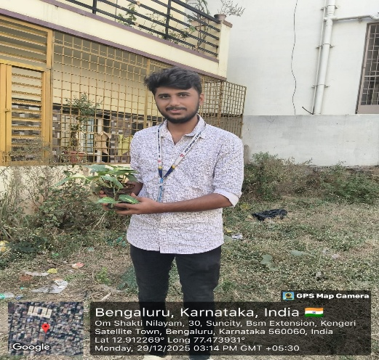

Fig 1.1:- money plant

**Site Selection for Plantation:**

When selecting a site for planting a Money Plant, the following factors should be considered:

i. **Light:** Money plants grow best in indirect sunlight. Avoid direct harsh sunlight.  
ii. **Accessibility:** Choose a place where watering and maintenance are easy.  
iii. **Drainage:** Ensure proper drainage to prevent waterlogging of roots.  
iv. **Air circulation:** Good airflow helps healthy growth of the plant.  
v. **Indoor/Outdoor suitability:** Can be planted indoors near windows or outdoors in shaded areas.  
vi. **Protection:** Keep away from extreme heat, cold, or strong winds.

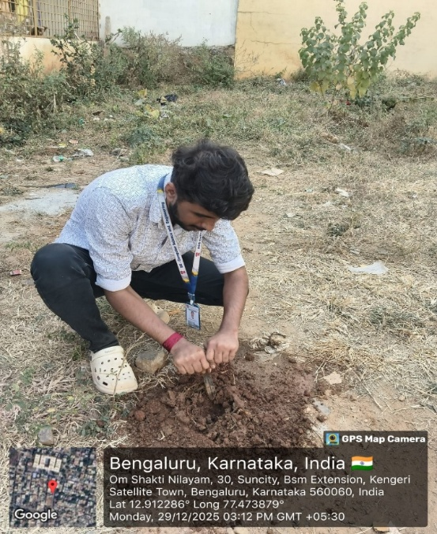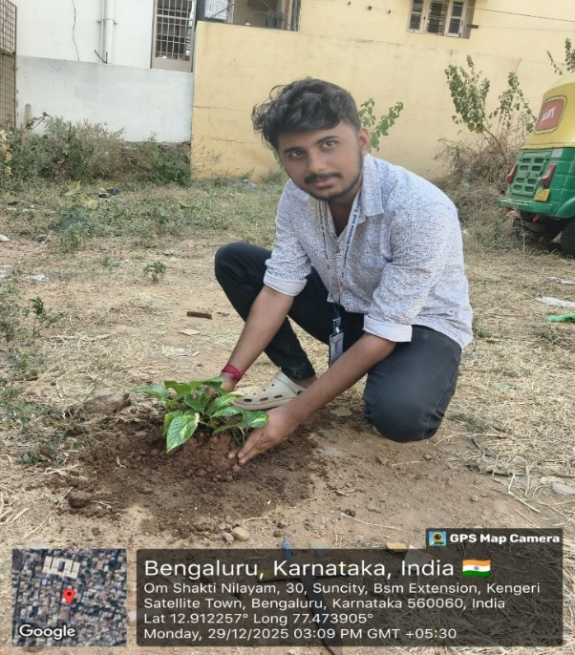

**Fig.1.2**:-plantation of money plant

**Benefits and Impacts:**

Plantation of Money Plant provides several environmental and health benefits. It helps purify air by absorbing harmful toxins such as carbon monoxide and formaldehyde. Money plants improve indoor air quality and increase oxygen levels.

Environmentally, Money Plants help reduce stress, enhance aesthetic value, and promote greenery. They require minimal care, making them ideal for sustainable plantation practices. Economically, they are low-cost plants and easily propagated. From an **environmental perspective**, Money Plants promote greenery and help in reducing the effects of air pollution. Their dense foliage absorbs dust particles and improves the micro-climate of the area. They also support sustainable plantation practices as they require minimal water, fertilizers, and maintenance.

The **economic impact** of Money Plants is also notable. They are low-cost, easily available, and can be propagated through cuttings, making them affordable for large-scale plantation. Their ornamental value increases the aesthetic appeal of buildings and landscapes, indirectly contributing to improved living and working conditions.

Socially, Money Plant plantation activities help in creating **environmental awareness** among students and communities. Adoption of the plant encourages responsibility, teamwork, and long-term care towards nature. Such activities promote sustainable habits and a positive attitude towards environmental conservation

**Conclusion:**

The Money Plant plantation activity was successfully carried out by me Prabhudev B & my team members. We thank the management of **ACS College of Engineering** for providing space and support for this plantation. The Money Plant is easy to maintain and provides long-term environmental and health benefits. By adopting and caring for the plant, we contribute to sustainable development and environmental protection. This activity helped us understand the importance of plantation and responsibility towards nature.

The Money Plant is an ideal choice for plantation due to its low maintenance requirements and high environmental benefits. Its ability to purify air, improve oxygen levels, and enhance indoor environmental quality makes it highly suitable for educational institutions. Regular monitoring and care ensured healthy growth of the plant and helped us develop discipline and teamwork.

This plantation activity also increased our awareness about sustainable development and the role of small-scale plantation in environmental conservation. It encouraged us to adopt eco-friendly practices and understand the long-term benefits of protecting natural resources. The project highlighted the importance of community participation and institutional support in promoting environmental initiatives.

## MODULE 2- HERITAGE WALK AND CRAFT CORNER

## Introduction:

Tipu Sultan’s Palace is one of the most important historical monuments in Bengaluru, reflecting the rich heritage and architectural brilliance of the Mysore Kingdom. Built in the late 18th century by Hyder Ali and completed by his son Tipu Sultan, the palace served as the summer residence of Tipu Sultan. The monument stands as a symbol of Tipu Sultan’s valor, administration, and contribution to Indian history. Today, the palace functions as a museum that preserves and showcases artifacts, paintings, and records related to Tipu Sultan’s life and reign, offering visitors a glimpse into the cultural and historical legacy of the period.

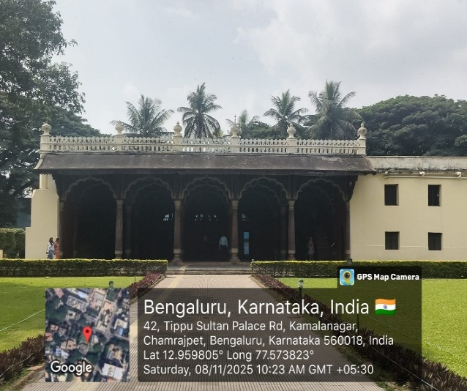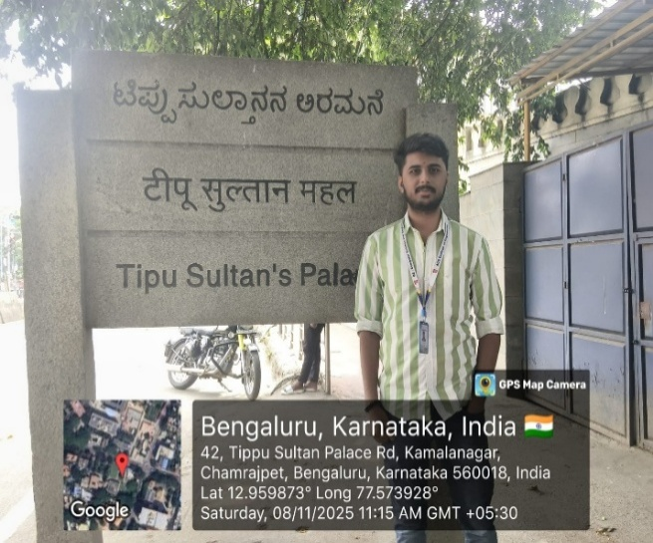

**Fig.2.1**:- Entrance of tipu sultan’s palace

**Overview:**

**Tipu Sultan’s Palace:**

Tipu Sultan’s Palace, also known as the **Bangalore Fort Palace**, is located in the heart of Bengaluru. It was originally built by **Hyder Ali** and later completed by **Tipu Sultan** in the year **1791**. The palace served as the summer residence of Tipu Sultan, who was the ruler of the Kingdom of Mysore.

The palace is constructed mainly of **teak wood** and is a fine example of **Indo-Islamic architecture**. It consists of beautifully carved pillars, arches, balconies, and floral motifs. The two-storeyed structure is supported by wooden columns and is known for its elegant craftsmanship.

Inside the palace, portraits of Tipu Sultan, his family members, and scenes from his life are displayed. Weapons, coins, costumes, and other historical artifacts related to Tipu Sultan are also exhibited. The palace reflects the bravery, patriotism, and administrative excellence of Tipu Sultan, who is famously known as the **“Tiger of Mysore.”**

The palace is an excellent example of Indo-Islamic architecture, combining Islamic design elements with traditional Indian craftsmanship. It is a two-storeyed structure built mainly using teak wood, with stone foundations. The palace features finely carved wooden pillars, arches, balconies, and ornamental brackets, showcasing the superior skill of artisans of that period. Floral designs and decorative motifs add to the aesthetic beauty of the structure**.**

Today, Tipu Sultan’s Palace stands as an important heritage site and tourist attraction. It not only preserves the architectural and historical legacy of the Mysore Kingdom but also educates visitors about the life, achievements, and patriotism of Tipu Sultan, making it a significant cultural landmark**.**



**Fig.2.2**:- Tipu sultan’s summer palace

**CRAFT CORNER: Museum of Art and Photography (MAP):**

The **Museum of Art and Photography (MAP)** is one of India’s first private museums dedicated to visual art. It is located in Bengaluru and houses a rich collection of artworks spanning several centuries. The museum aims to preserve, display, and promote Indian art, culture, and heritage.

MAP showcases a wide variety of collections including **paintings, sculptures, photographs, textiles, and decorative arts**. The artworks represent different regions of India and reflect social, cultural, and historical themes. The museum also includes modern and contemporary art along with traditional Indian art forms.

The building of the museum is designed in a modern architectural style with well-planned galleries and interactive spaces. Visitors can engage with digital displays and educational resources that enhance the learning experience. The museum plays an important role in spreading awareness about India’s artistic legacy and encouraging appreciation of art among people.

The museum building is designed with a **contemporary architectural style**, incorporating well-lit galleries, climate-controlled exhibition spaces, and interactive digital installations. These modern facilities enhance the visitor experience and allow for deeper engagement with the artworks. MAP also organizes **educational programs, workshops, exhibitions, and guided tours**, encouraging learning and cultural awareness among students and visitors.

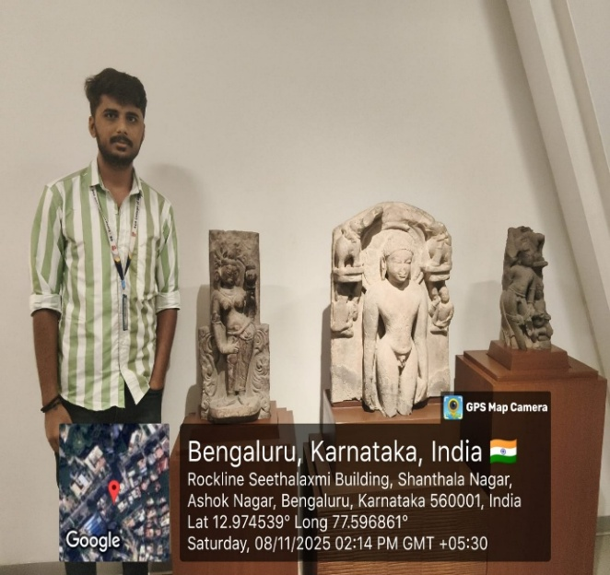

**Fig.2.3**:- museum of art & photography (MAP)

**Conclusion:**

The visit to the **Museum of Art and Photography (MAP)** was an enriching and educational experience that provided deep insight into India’s artistic and cultural heritage. The museum successfully brings together traditional, modern, and contemporary art forms under one roof, helping visitors understand the evolution of Indian art across different periods. Through its well-curated exhibits, interactive displays, and educational initiatives, MAP promotes appreciation for visual arts and cultural diversity. Overall, the museum plays a vital role in preserving artistic heritage and inspiring creativity, making it an important cultural landmark and a valuable learning destination for students and visitors alike.

The thoughtfully designed galleries and modern display techniques enhance understanding and appreciation of the artworks. Interactive exhibits and educational resources encourage active learning and help visitors connect historical art forms with contemporary perspectives. MAP also plays a significant role in preserving rare and valuable artworks, ensuring that India’s cultural heritage is safeguarded for future generations.

Overall, the Museum of Art and Photography serves not only as a space for exhibition but also as a center for education, creativity, and cultural dialogue. The visit helped deepen our appreciation for art and history, making MAP an important institution for learning and cultural awareness.

## MODULE 3 – ORGANIC FARMING AND WASTE MANAGEMENT

## 

**ORGANIC FARMING :**

**Introduction**

Organic farming and waste management are key pillars of sustainable development and environmental protection. Rapid industrialization, urbanization, and population growth have increased the demand for food and resources, while also generating large amounts of waste. Conventional farming methods that rely heavily on chemical fertilizers and pesticides have caused soil degradation, water pollution, and loss of biodiversity. Similarly, improper waste management has resulted in environmental pollution, health hazards, and climate change issues.

Organic farming promotes eco-friendly agricultural practices by maintaining soil fertility, conserving natural resources, and producing healthy food without harmful chemicals. Waste management focuses on the systematic handling of waste through collection, segregation, recycling, composting, and safe disposal. When integrated, organic farming and waste management form a closed-loop system where organic waste is converted into valuable inputs such as compost and biofertilizers, contributing to sustainability.

**Organic Farming**

Organic farmers focus on building and maintaining healthy soil through practices such as crop rotation, cover cropping, composting, and the use of natural soil amendments like manure and organic matter. Healthy soil is crucial for nutrient retention, water retention, and promoting beneficial microorganisms that support plant growth

Organic farming encourages crop diversity, both within individual fields and across the farm. Crop rotation helps prevent soil erosion, reduces pest and disease pressure, and improves soil fertility by varying the types of plants grown in a particular area over time

Instead of relying on synthetic pesticides and herbicides, organic farmers use techniques such as integrated pest management (IPM), biological control, beneficial insect habitat enhancement, and physical barriers to manage pests and diseases. This approach minimizes harm to beneficial insects, pollinators, and other wildlife

Organic farming prohibits the use of synthetic chemicals, including synthetic fertilizers, pesticides, herbicides, and genetically modified organisms (GMOs). Instead, farmers use natural and organic inputs such as compost, manure, crop residues, and botanical extracts to nourish plants and manage pests

**Principles of Organic Farming**

1. **Health** – Sustains the health of soil, plants, animals, humans, and the planet.
2. **Ecology** – Works with natural ecosystems rather than against them.
3. **Fairness** – Ensures fair relationships and good quality of life for all stakeholders.
4. **Care** – Adopts precautionary and responsible farming practices.

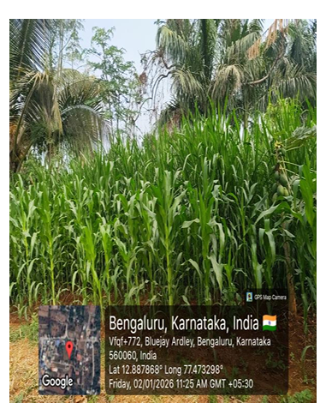

Fig 3.1 :- Organic Forming

**Process of Organic Farming**

1. **Land Preparation** – Soil is prepared using natural methods to enhance fertility.
2. **Seed Selection and Sowing** – Use of organic and untreated seeds.
3. **Manure and Compost Application** – Natural fertilizers are applied to enrich soil.
4. **Crop Growth Management** – Regular monitoring of crop health.
5. **Pest and Weed Control** – Use of biological and mechanical methods.
6. **Harvesting** – Crops are harvested at maturity without chemical residues.
7. **Post-Harvest Handling** – Storage and processing using eco-friendly methods

**WASTE MANAGEMENT**

Waste management refers to the systematic process of collecting, segregating, transporting, treating, and disposing of waste in an environmentally safe and sustainable manner. With rapid population growth, urbanization, industrialization, and changing lifestyles, the quantity and complexity of waste generated have increased significantly. Improper waste management leads to environmental pollution, health hazards, and degradation of natural resources

Effective waste management aims to reduce waste generation, promote recycling and reuse, recover useful resources, and ensure safe disposal of residual waste. It plays a vital role in maintaining public health, protecting ecosystems, and supporting sustainable development

**Objectives of Waste Management :**

1. To minimize waste generation at source
2. To promote segregation of waste
3. To reduce environmental pollution
4. To protect human health and hygiene
5. To encourage recycling and reuse
6. To ensure safe and scientific disposal of waste
7. To conserve natural resources

**Challenges in Waste Management :**

Waste management faces several challenges due to rapid population growth, urbanization, and changing lifestyles. One of the major challenges is the lack of proper waste segregation at the source. When wet, dry, and hazardous wastes are mixed together, it becomes difficult to recycle or treat them effectively, leading to increased landfill waste and environmental pollution. Limited public awareness and irresponsible disposal practices further worsen this problem.

Another significant challenge is inadequate infrastructure and technology for waste collection, transportation, and processing. Many areas lack sufficient waste treatment facilities such as composting units, recycling plants, and sanitary landfills. As a result, waste is often dumped in open areas or poorly managed landfills, causing air, water, and soil pollution. Insufficient funding and poor maintenance of waste management systems also affect their efficiency.

**Usefulness of Organic Farming and Wet Waste Management in Neighbouring Villages :**

Organic farming and wet waste management play an important role in improving the environmental, economic, and social conditions of neighbouring villages. Organic farming helps farmers maintain soil fertility by using natural inputs such as compost, green manure, and biofertilizers. This reduces dependence on chemical fertilizers and pesticides, leading to healthier soil, better water retention, and sustainable crop production. As a result, villagers get access to safe, chemical-free food, which improves overall health and nutrition.

Wet waste management is highly useful in villages where a large amount of biodegradable waste is generated from households, agriculture, and livestock. Kitchen waste, crop residues, and animal dung can be effectively converted into compost or vermicompost. This organic manure can be used directly in farms, reducing input costs for farmers and increasing crop yield naturally. Biogas plants set up using wet waste provide clean cooking fuel and reduce dependence on firewood, thereby protecting forests and improving indoor air quality.

The integration of organic farming with wet waste management promotes a circular economy in neighbouring villages. Waste generated in households and farms is recycled back into agriculture as valuable resources. This reduces environmental pollution, prevents open dumping, and keeps the surroundings clean and hygienic. It also creates employment opportunities in composting, vermiculture, and organic input production, contributing to rural livelihoods.

**Conclusion:**

Several campuses have implemented successful waste management practices. For example, the University of California, Davis, has implemented a zero waste policy, where all waste generated on campus is either recycled or composted. The ACS College of Engineering has implemented a composting program that diverts food waste from the landfill and uses it to fertilize campus gardens and landscapes

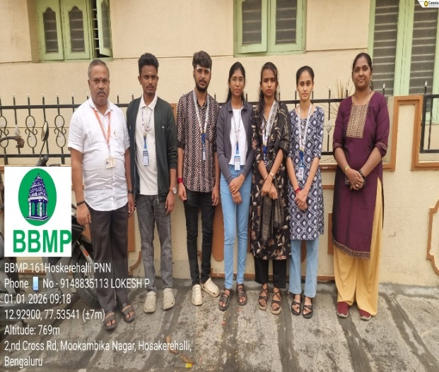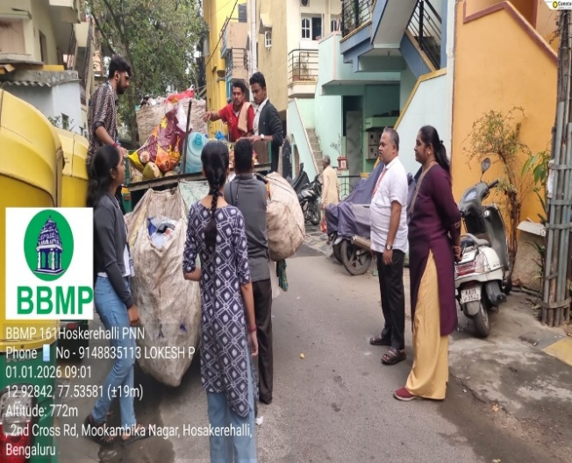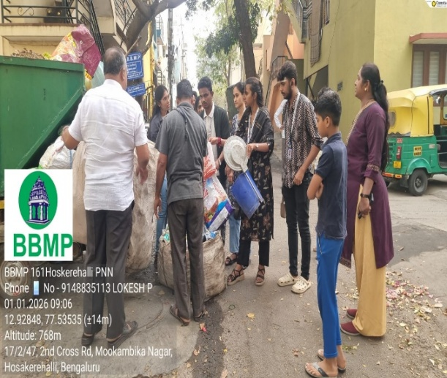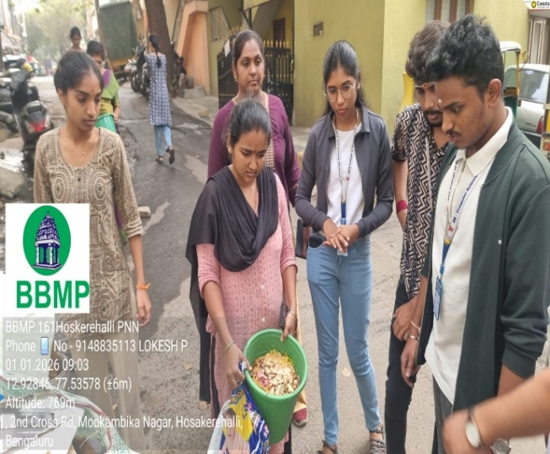

## Fig:- 3.2 waste management

## MODULE 4 - WATER CONSERVATION

**Introduction:**

Water conservation refers to the careful and efficient use of water to reduce wastage and ensure its availability for present and future generations. Water is a limited and valuable natural resource that is essential for life, agriculture, industry, and ecosystem balance. Due to population growth, urbanization, climate change, and over-exploitation of water resources, many regions face water scarcity. Water conservation aims to protect water resources through responsible usage, management, and sustainable practices.

**Importance of Water Conservation:**

Water conservation is essential to ensure sufficient water supply for drinking, irrigation, industrial use, and environmental sustainability. Conserving water helps maintain groundwater levels and prevents the depletion of rivers, lakes, and reservoirs. It supports agricultural productivity, protects aquatic ecosystems, and preserves biodiversity. Water conservation also reduces the impact of droughts and water shortages, especially in regions with irregular rainfall.

Reducing excessive water use helps lessen the effects of water scarcity and drought, especially in regions facing limited water supply. Since water treatment and distribution require significant energy, conserving water also helps save energy and reduce greenhouse gas emissions, thereby contributing to climate change mitigation.

Water conservation leads to economic benefits by lowering water bills and reducing costs related to water infrastructure and maintenance. As climate change increases the frequency of water shortages, conservation practices help communities become more resilient and better prepared for uncertain water availability. Additionally, conserving water helps preserve natural landscapes and ecosystems that have ecological, cultural, and recreational importance.

**Need for Water Conservation:**

The increasing demand for water, combined with limited freshwater resources, makes water conservation necessary. Rapid urban growth, industrialization, and inefficient water usage have led to water stress in many areas. Climate change further worsens the situation by causing unpredictable rainfall patterns and prolonged dry periods. Water conservation helps address these challenges by promoting sustainable water use and reducing dependence on scarce water sources.

**Methods of Water Conservation:**

Water conservation can be achieved through various methods such as fixing leaks, using water-efficient appliances, practicing rainwater harvesting, recycling wastewater, and adopting efficient irrigation techniques like drip and sprinkler systems. In households, simple practices like turning off taps when not in use and reusing water can significantly reduce wastage. In agriculture and industries, modern technologies help optimize water use and improve efficiency.

**Rain water harvesting:**

Rainwater harvesting is the process of collecting, storing, and using rainwater for various purposes. The primary objective of rainwater harvesting is to conserve water and minimize the use of groundwater sources, which are often over-exploited and depleting. Rainwater harvesting is an ancient practice that has been used for centuries in many parts of the world to collect and store rainwater for drinking, cooking, irrigation, and other household uses. Rainwater harvesting has many benefits, including reducing the demand for groundwater sources, preventing floods, improving water quality, and providing an alternative source of water during droughts. Rainwater is also free from contaminants that are commonly found in groundwater sources and is ideal for non-potable uses such as irrigation, toilet flushing, and cleaning

**Role of Water Conservation in Environmental Protection:**

Water conservation plays a crucial role in protecting the environment by maintaining natural water bodies and ecosystems. It helps reduce water pollution, prevents soil erosion, and supports the survival of aquatic life. Conserving water also saves energy, as less energy is required for water treatment and transportation, thereby reducing greenhouse gas emissions and combating climate change.

The process of rainwater harvesting usually includes collection, filtration, storage, and reuse. Rainwater falling on rooftops is collected through pipes and gutters and passed through a filtration system to remove dust, leaves, and debris. The filtered water is then stored in tanks or directed into recharge pits, wells, or percolation tanks to replenish groundwater. Proper maintenance of filters and storage systems ensures good water quality.

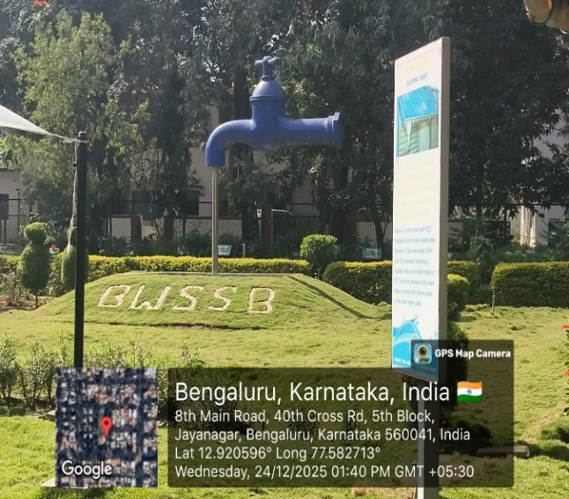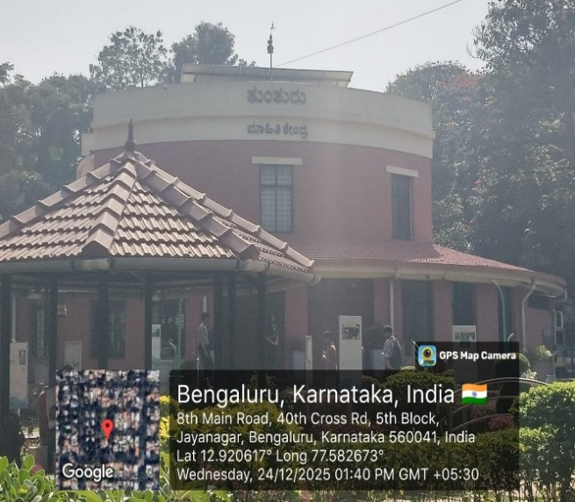

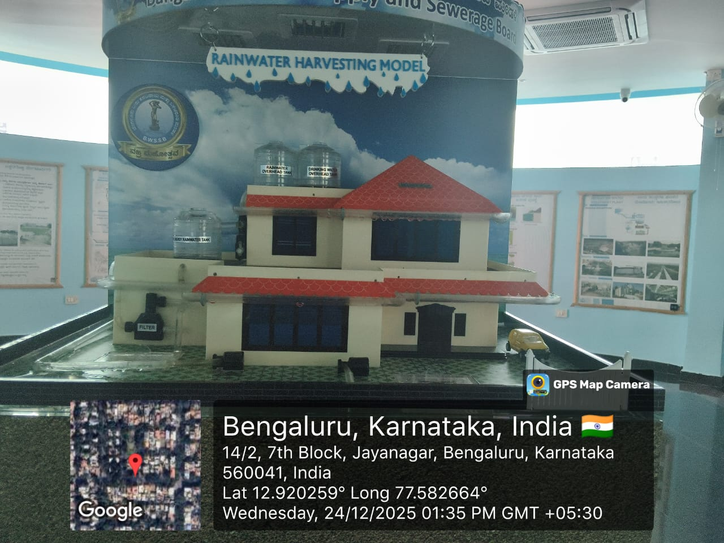

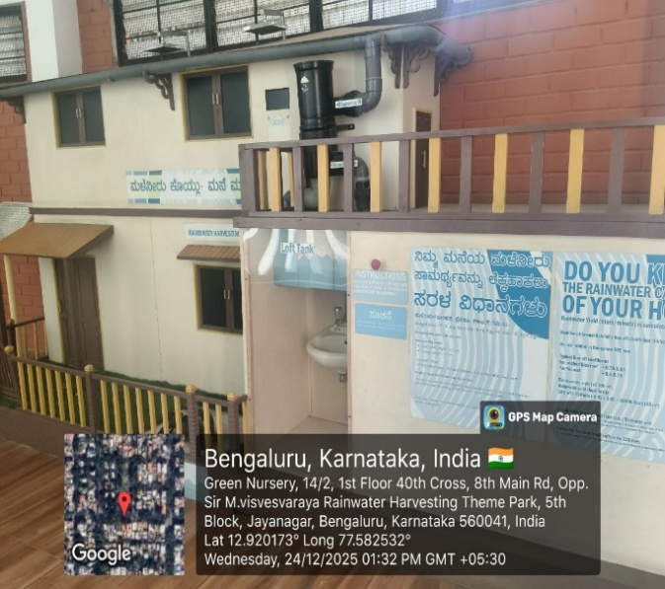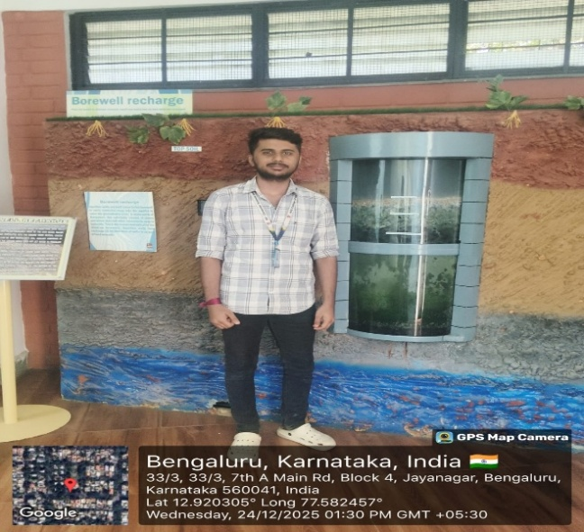

**Fig.4.1 : water conservation**

**Water Conservation in Institutions and Communities:**

Educational institutions, industries, and communities can contribute to water conservation by implementing efficient water management systems, installing rainwater harvesting structures, monitoring water usage, and creating awareness among people. Community participation and education are vital for promoting responsible water use and long-term conservation practices.

**Conclusion:**

Water conservation is a shared responsibility that requires the collective efforts of the entire campus community. By implementing the proposed initiatives and fostering a culture of water conservation, ACS College of Engineering can reduce its environmental footprint, promote sustainability, and serve as a role model for other institutions. Together, we can make a significant impact in preserving this precious resource for future generations.

Water conservation is a shared responsibility that requires collective efforts from individuals, communities, institutions, and governments. By adopting water-saving practices and sustainable management strategies, we can protect water resources, ensure water security, and preserve the environment for future generations. Effective water conservation not only supports human needs but also maintains ecological balance and sustainable development.

Adopting methods such as rainwater harvesting, groundwater recharge, drip irrigation, reuse of greywater, and protection of water bodies helps in preserving water resources. Public awareness, community participation, and government initiatives together can create a strong impact on water conservation efforts. When individuals take responsibility for saving water in daily life, it leads to long-term benefits for society and nature.

In conclusion, water conservation is not just an option but a necessity. Saving water today ensures food security, supports biodiversity, and guarantees a better quality of life for future generations. Every small effort counts, and collective action can make a significant difference in protecting this precious resource for a sustainable future.

.

## MODULE 5 – FOOD WALK

## Introduction:

## A food walk is an engaging activity that helps individuals explore local eating habits and traditional street food in a specific area. It allows participants to experience regional flavors, understand food preparation methods, and observe the cultural importance of street food in daily life.

**Purpose:**

The aim of this report is to present a detailed account of the food walk conducted at Vijayanagar Food Street and to explain its importance in showcasing Bangalore’s street food culture.

**Methodology:**

Information for this report was gathered through personal participation in the food walk, direct observation of food stalls, and informal conversations with street food vendors at Vijayanagar Food Street.

**Overview:**

Vijayanagar Food Street is a well-known food hub in Bangalore that offers a wide range of street food items at reasonable prices. The food walk involved moving through the food street, visiting selected stalls, and tasting commonly preferred local snacks. The experience highlighted the vibrant atmosphere and diversity of street food available in the area.

**Significance:**

Food walks help preserve local food traditions and support small vendors by increasing customer awareness. Vijayanagar Food Street plays a key role in promoting traditional and modern street food while providing livelihood opportunities for local sellers.

**Impact on the local Economy :**

Street food destinations like Vijayanagar Food Street contribute to the local economy by generating regular income for vendors and creating employment. The food street attracts residents and visitors alike, which helps boost daily sales and supports small-scale businesses.

**Challenges:**

Ensuring cleanliness and food safety is one of the major challenges faced by street food vendors. Maintaining hygiene during food preparation and managing large crowds, especially during evenings and weekends, are significant concerns.

**Indigenous materials of the region used in cooking and their impact on environment:**

The street food prepared at Vijayanagar Food Street uses ingredients commonly found in South Indian cuisine

**Rice:**

Rice is used to prepare dosa batter. While rice farming supports local agriculture, it requires large quantities of water, which can impact water resources if not managed carefull

**Lentils:**

Lentils are an essential component of dosa batter and contribute to soil enrichment. However, intensive cultivation may affect land quality.

**Vegetables:**

(Cauliflower and Lime): Cauliflower used in gobi and lime used in lime soda are sourced from local farms. Excessive use of chemicals in farming can negatively affect soil and water ecosystems.

Overall, the use of locally available ingredients supports traditional cuisine and farming communities. Sustainable agricultural practices are necessary to minimize environmental harm.

**Food Walk Experience:**

On 31th December 20235, participants took part in a food walk at Vijayanagar Food Street in Bangalore. The walk focused on experiencing popular street food items and gaining insight into the everyday food culture of the locality.

**Route and Stops:**

The food walk covered multiple stalls along Vijayanagar Food Street. Participants sampled the following food items

**Gobi:**

Spicy and crispy cauliflower fry prepared fresh at the stall, representing a popular street food snack

**Dosa:**

A traditional South Indian dish served with chutney and sambar, showcasing regional culinary practices

**Lime Soda:**

A refreshing local beverage enjoyed alongside the street food.

**Highlights: -**

Culinary Diversity: Participants experienced the rich diversity of Bangaluru cuisine, from traditional South Indian fare to regional specialties and street food delights. - Local Interactions: Interactions with local vendors, chefs, and fellow food enthusiasts provided valuable insights into Bangalore's culinary traditions, food culture, and culinary heritage.

Authentic Experiences: The food walk offered authentic, off-the-beaten-path culinary experiences, allowing participants to discover hidden culinary gems and sample authentic local flavers

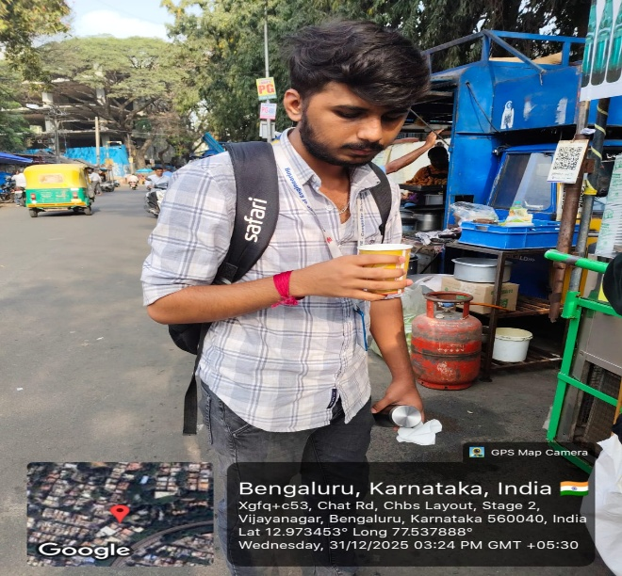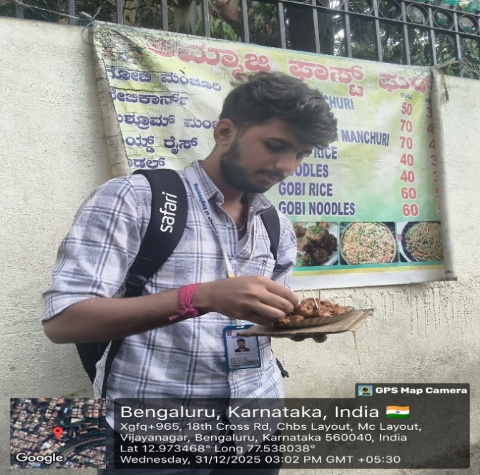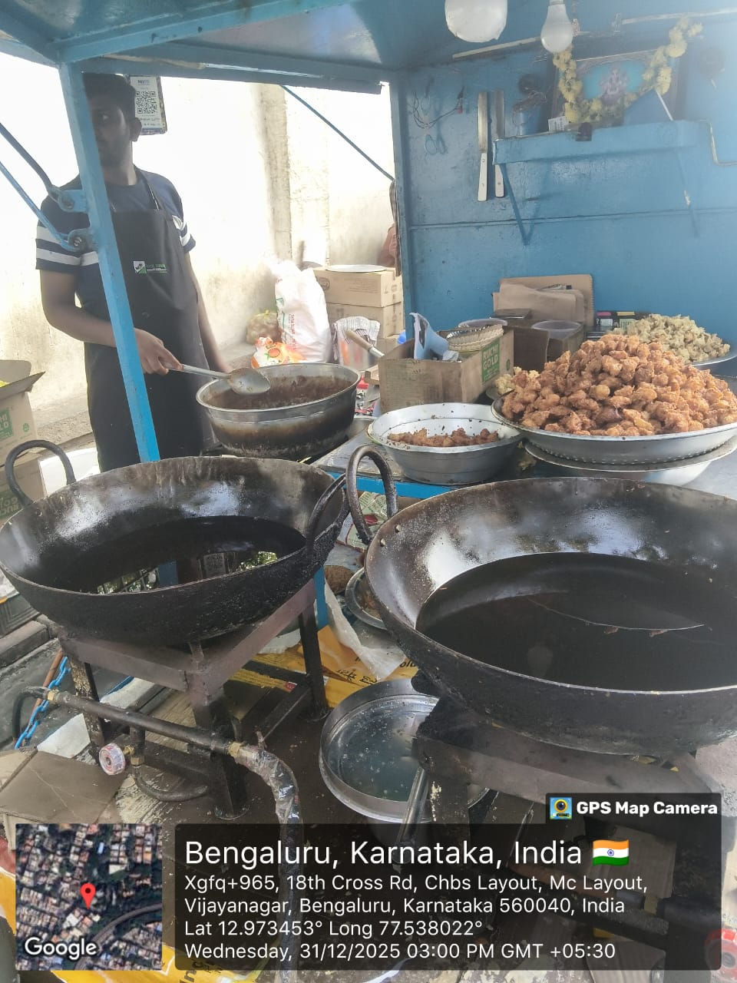

**Conclusion:**

The food walk at Vijayanagar Food Street provided a meaningful understanding of Bangalore’s street food culture and everyday eating practices. The experience highlighted the importance of street food in preserving local culinary traditions while offering affordable and flavorful meals to the community. Sampling popular items such as gobi, dosa, and lime soda allowed participants to appreciate the simplicity and authenticity of regional cuisine.

The foodwalk also demonstrated the positive impact of street food on the local economy by supporting small vendors and generating employment opportunities. Despite challenges related to hygiene and crowd management, Vijayanagar Food Street remains an important cultural and economic space. Overall, the food walk served as an educational and enjoyable experience, emphasizing the need to support local food vendors and promote sustainable practices in street food culture.

The Vijayanagar Food Walk creates awareness about **local employment**, as many families depend on small food businesses for their livelihood. It highlights the importance of supporting local vendors and preserving traditional food culture in urban areas.

Overall, the Vijayanagar Food Walk is an educational and engaging SCR activity that promotes **cultural awareness, social responsibility, healthy eating habits, and respect for local communities**. It helps students connect classroom learning with real-life experiences and encourages responsible citizenship.

**SUMMARY**

1 As part of an environmental responsibility initiative, a money plant was planted and will be nurtured for the next four years by Prabhudev B along with team members. The plantation activity was carried out on 29th December at Kengeri, Bangalore, and regular care will be taken to ensure healthy growth

2. A heritage walk was conducted on 8th November at Tipu Sultan’s Summer Palace, located in Bangalore. The visit helped participants gain knowledge about the historical importance, architectural style, and cultural heritage associated with the monument.

3. The college promotes sustainable waste management practices by minimizing waste generation and encouraging responsible disposal methods. Segregation of waste at the source and eco-friendly handling of biodegradable waste help reduce environmental impact and support a cleaner campus.

4. Water conservation plays a vital role in protecting natural resources and ensuring water availability for the future. Practices such as rainwater harvesting, efficient water usage, repairing leakages, reuse of water, and spreading awareness help in conserving water effectively.

5. Food walks provide an engaging platform to explore local cuisines and understand cultural diversity. They encourage learning through experience, promote social interaction, and offer a deeper appreciation of regional food traditions, making them both enjoyable and educational.

**CONCLUSION**

Building strong social connections and accepting responsibility are key to creating a positive and sustainable society. When individuals and organizations work together and take ownership of their actions, they contribute to social progress and environmental protection. Social responsibility should be practiced consistently and thoughtfully to create long-term positive outcomes. Organizations that follow ethical decision-making can prevent harmful effects and strengthen trust with employees, customers, and the wider community. On a personal level, individuals must make responsible and sustainable choices, ensure accountability, and promote ethical practices. In conclusion, social responsibility plays a vital role in benefiting society as a whole and protecting the environment for future generations.

Social connection and responsibility are essential for creating a better world for everyone. By working together and taking responsibility for our actions, we can advance social goals and improve the environment. Social responsibility can be practiced passively or actively, and it must be intergenerational to have a lasting impact. Businesses that practice ethical decision making can avoid negative consequences and build stronger relationships with customers, employees, and the community. As individuals, we must make sustainable and ethical decisions, hold organizations accountable, and encourage sustainable practices. Ultimately, social responsibility benefits everyone, and all individuals and organizations must contribute to the greater good of society and the environment